Org Analysis Product Update

December 2025 - January 2026
Date: January 2026
Period Covered: December 1, 2025 - January 21, 2026

Executive Summary
This reporting period saw significant product advancement with the delivery of three major new capabilities that directly address customer needs around Salesforce governance, compliance, and cost optimization. These features strengthen our competitive position by providing insights that are difficult or impossible to obtain through native Salesforce tools.

Key Highlights
- Change Tracking - New feature providing complete visibility into who modified what and when across the entire Salesforce org
- Salesforce Users Dashboard - Centralized user management and activity visibility
- Field Usage Analysis - AI-powered identification of unused custom fields for cleanup and license cost reduction
- Enhanced Business Process Analysis - Expanded support for Flows and Process Builder automation

New Features

1. Change Tracking
Business Value: Enables organizations to maintain audit trails, support compliance requirements, and understand who is actively maintaining their Salesforce configuration.
Change Tracking automatically captures modification history across all Salesforce metadata, attributing changes to specific users. This addresses a critical gap in native Salesforce functionality where historical change information is often lost or difficult to aggregate.
Key Capabilities:
- Organization-wide change visibility - See all configuration changes in one place, sorted by date or user
- User contribution analysis - Identify who is actively maintaining the org and their areas of focus
- Top 20 Contributors chart - Visual representation of most active configuration maintainers
- Per-user detail views - Drill down into any user to see their complete modification history including:
  - Objects and fields they've modified
  - Business processes they've created or updated
  - Activity histograms showing when they're most active
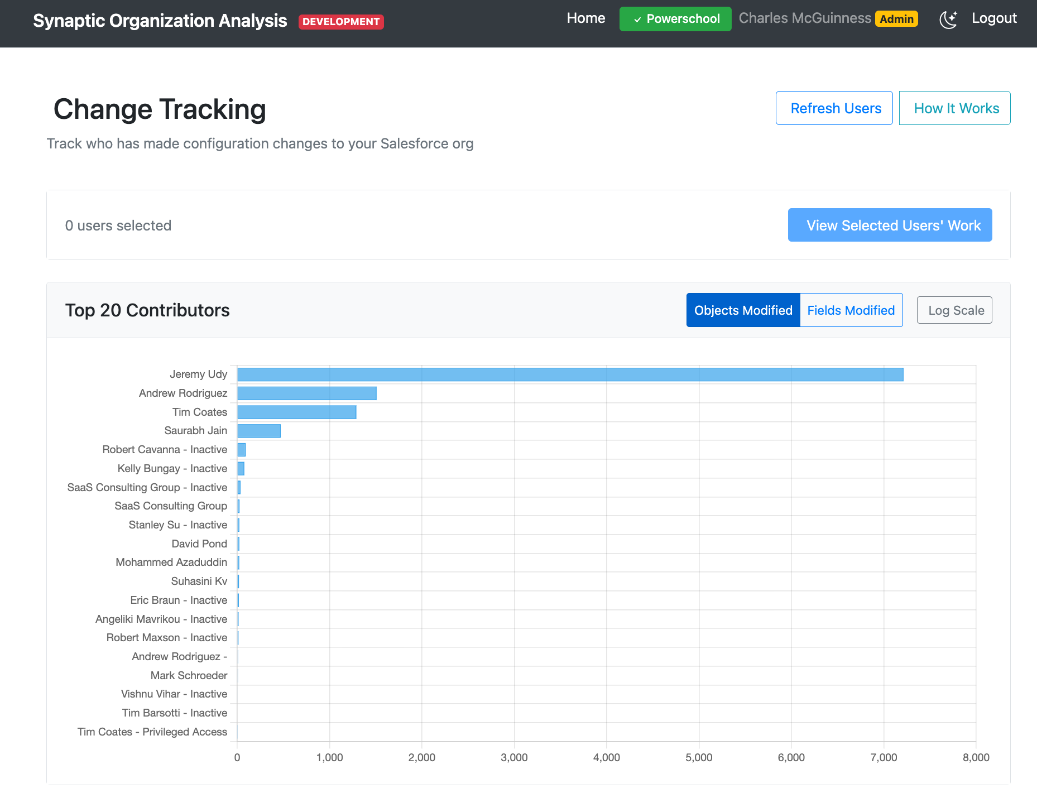
Screenshot: Change Tracking main page showing recent modifications and top contributors chart

2. Salesforce Users Dashboard
Business Value: Provides centralized visibility into the Salesforce user base, supporting license management and access governance.
A dedicated top-level feature for viewing and analyzing Salesforce users within the connected organization.
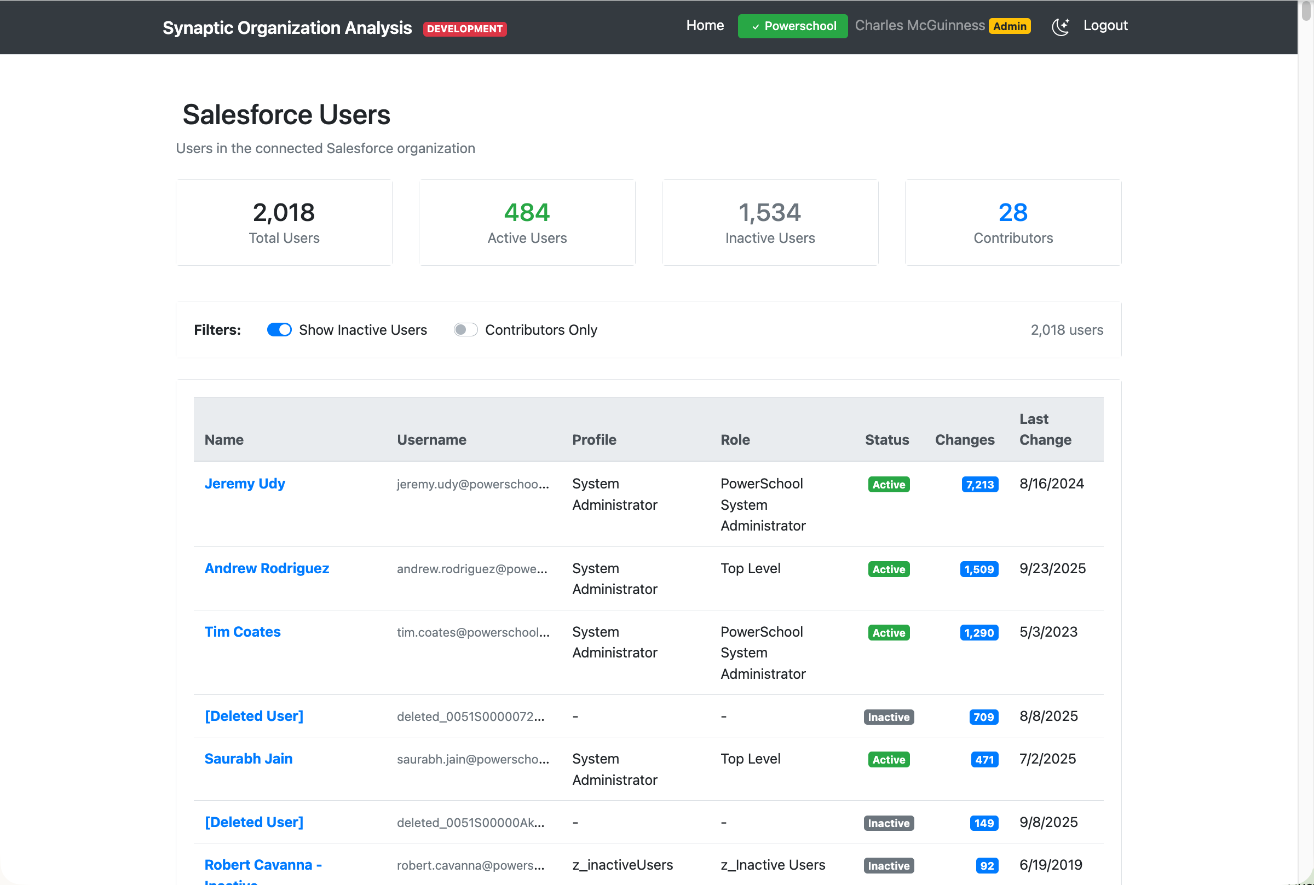
Screenshot: Salesforce Users dashboard showing user list with key attributes

3. Field Usage Analysis
Business Value: Identifies unused custom fields that can be safely removed, reducing technical debt and potentially lowering Salesforce licensing costs (custom field limits are a common constraint).
This feature uses statistical sampling to analyze actual data usage patterns across custom fields. It identifies:
- Used fields - Fields that contain data and are actively being populated
- Unused fields - Custom fields that contain no data and are candidates for removal
- Usage confidence levels - Statistical confidence in the analysis results
For large objects with millions of records, the system uses intelligent sampling to provide accurate results without requiring a full table scan.
Key Capabilities:
- One-click analysis from any object detail page
- Exportable CSV reports for governance documentation
- Confidence scoring based on sample size and data distribution
- Date range tracking showing when fields were first and last populated
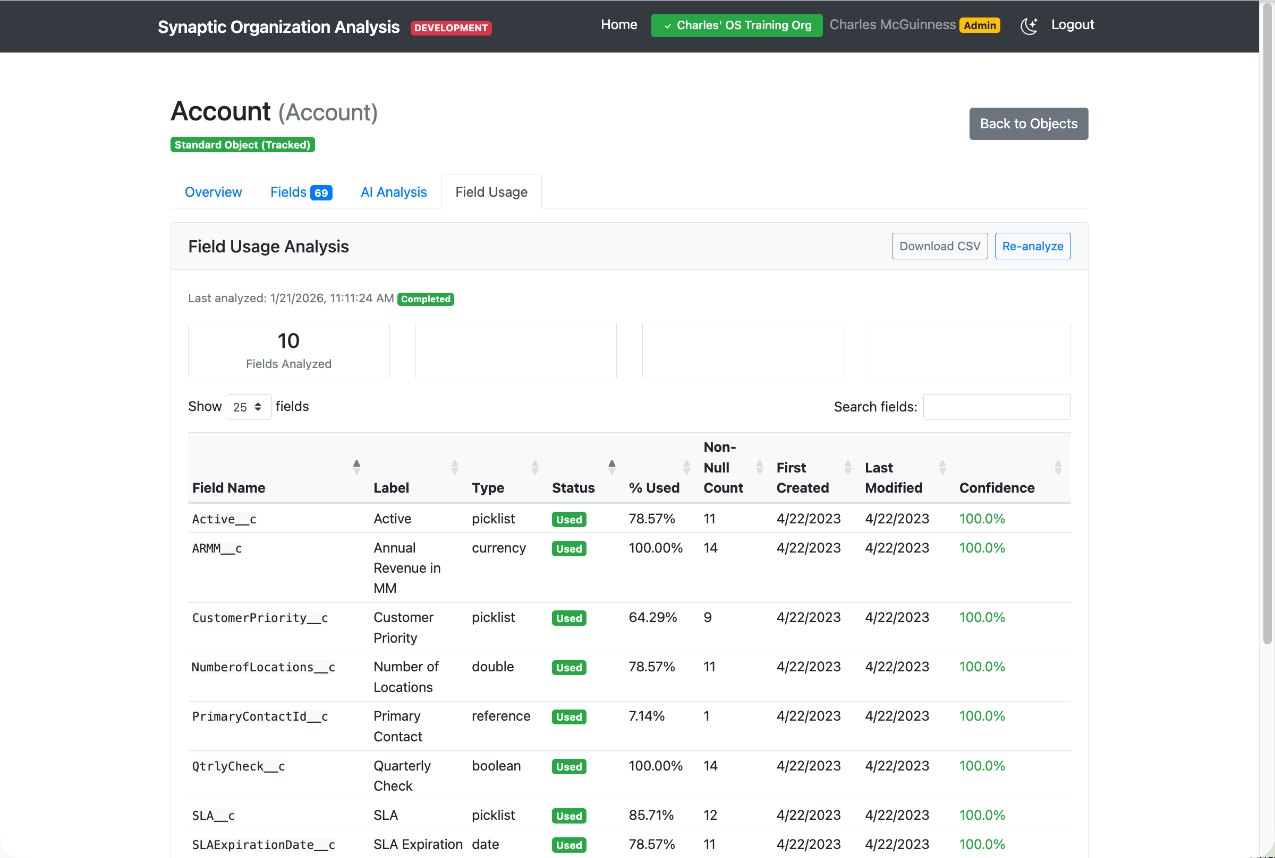
Screenshot: Field Usage tab showing analysis results with usage status, percentages, and confidence levels

4. Enhanced Business Process Analysis
Business Value: Expanded automation visibility to include modern Salesforce automation tools, providing complete coverage of business logic.
Building on our existing Process Builder support, we've added comprehensive analysis for:
- Salesforce Flows - The primary modern automation tool in Salesforce
- Combined AI Analysis - Object analysis now includes related business processes for a complete picture
This ensures customers have visibility into all automation regardless of which Salesforce tool was used to build it.

Platform Improvements

Improved Progress Tracking
Background jobs now display multi-phase progress with descriptive status messages, giving users better visibility into long-running operations.

Record Count Visibility
Object listings now include approximate record counts, helping users prioritize which objects to analyze and understand data volumes.

Enhanced Filtering
The Fields tab on object detail pages now includes filters for field type, custom vs. standard, and other attributes, making it easier to find specific fields in objects with hundreds of fields.

Technical Metrics
Metric | Value
Commits this period | 45
New database tables | 4
New API endpoints | 8
New UI pages/tabs | 6

Looking Ahead
The Field Usage Analysis feature establishes a foundation for broader data quality and governance capabilities. Planned extensions include:
- Field dependency mapping - Understanding which fields are referenced by formulas, validation rules, and automation
- Cleanup recommendations - Guided workflows for safely removing unused fields
- Historical trend analysis - Track field usage changes over time

